

**Project Report**

**Project Title: Color Detection using OpenCV**

**Course Title: Machine Learning**

**Course Code: CSE475**

**Section: 03**

**Submitted to:**

Dr. Samiullah

Adjunct Faculty

Department of Computer Science and Engineering

East West University

**Submitted by:**

|  |  |
| --- | --- |
| **Name** | **ID** |
| Meharaj – Ul- Mahmmud | 2018-2-60-067 |
| Md. Ahsan Ahmed | 2018-2-60-029 |
| Md. Maiyaz Al Mahmud | 2018-2-60- |

**Date of Submission:**

08th Sept. 2021

1. **Introduction**

The concept of color detection is to detect color from a still image or a video feed. Color detector systems are required in many surveillance processes. The aim of our project is to use deep learning methods such as image processing to make a system for color detection to be implemented in camera surveillance.

Color detection is important in every expect of life. Let us imagine a CCTV camera records a murder incident. In this scenario if the CCTV cam has a color detection system along with responsive AI implemented, it can alert all the police stations nearby making it easy for the law enforcement authorities to respond fast and swiftly. This may drop crime rate and may help lessen accident occurrences. For that kind of noble purpose, we chose this project of color detection.

1. **Background Study**

Color detection process in deep learning is much similar to that of a human brain. A human brain is connected to eyes through visual cortex and optic nerve. When light hits an object it reflects a certain wavelength and absorbs the rest. When it enters the eye through cornea the eye can differentiate the color of the light through some complex process. The lights have wavelength. Because of the differing wavelength the color can be easily detected. So, for eyes the wavelength are the color codes that indicates which color of light entering through cornea. The retina is also covered with millions of color sensitive cells. The cone sells which can detect color in high intensity lighting. The rod cells mostly detect black and white color information.

In our project the color detection process is somewhat same. For this process the RGB codes acts like the wavelength in real scenario. The system processes the image or media file pixel by pixel and for every pixel matches with the RGB codes. Then the outputs are collected to create the final result. Like wavelength in our system there is defined upper and lower boundary for HSV format. Some limitations are there for using RGB code. The RGB codes are generated through the mix of Red, Green and Blue color. So, our system may not be able to detect complex color combination. The concept of color detection in various light intensity is also required in a color detection system.

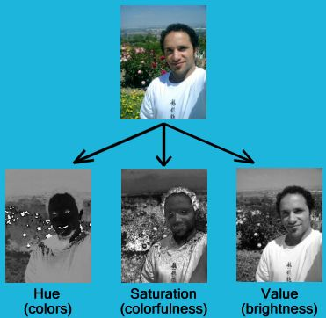

In a RGB image the three colors Red, Blue and Green are combined to make nearly 16 million colors. The RGB images needs to processed in order to implement color detection. For this purpose, images are HSV (Hue, Saturation, Value) format. HSV is one of the hue image format and the other being HSL. In RGB format the image is 3 dimensional matrixes where each dimension represents the three colors. RGB works with only color components ignoring the other more important components that may affect the color detection process. For if someone holds a light at a red object it will create more bright and shady area on the object. The shady area will look more deep red while the bright area will seem lighter. As RGB format uses only color components the system may accidentally different values for same color. For this reason, HSV can be a good solution. The HSV separates color intensity from color chromaticity. For different shades the HSV values differs so that the RGB value does not deviate so much making it easier for the system to detect color.

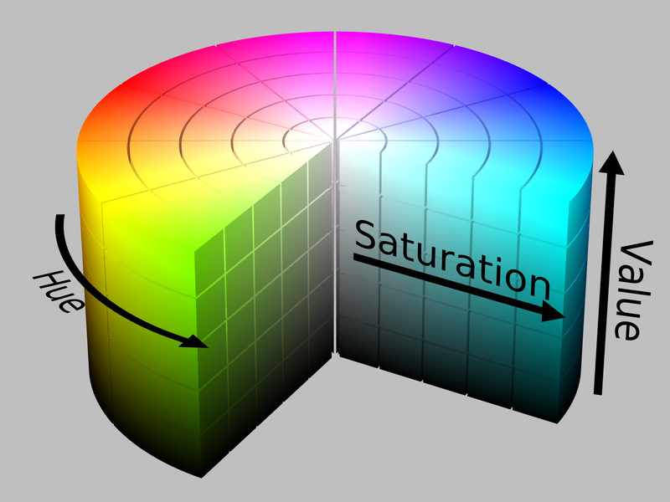

In HSV format it is easy to use color mask to separate different colors from one another. In color detection the color masks are used to point out the area of certain color. The area contains all the pixel area that has the same RGB value. This is how the system can easily detect the colors from the RGB value and pixel values.

1. **Idea and Implementation**

**Idea**: The idea for implementing this project was to first capture a video stream from a camera, which could be mobile phone camera, or web camera. Our program is able to capture the video stream from mobile phone camera as well as web cam.

The stream comes into the program as frame by frame for processing as RGB. Our program is able to catch 30 frames per second. Then we are converting each of the RGB frame to HSV frame. After that we will define an upper limit and a lower limit for each of the colors, we want our program to detect.

Then we are applying a specific-colored mask over the specific color our program is detecting. The idea of applying a mask is when our program is getting a certain pixel’s RGB value within the range of any defined color then by applying the mask we are getting a hold of that certain pixel.

When we get a pixel of certain color then we display a rectangle around that pixel with a header named as the color name. And usually, we do not get one pixel from a certain color, its more than hundreds of pixels of same color stay together. So, we display the rectangle around the whole area of a certain color.

**Implementation:**

**Capturing video feed**



**Setting upper limit and lower limit for colors**



**Applying bitwise and operator between the image frame and color masks**



**Displaying rectangle around the color area**



1. **Experimentation**

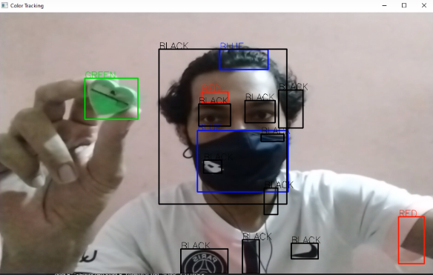We did live experimentation on streaming video. For this purpose, a mobile application named IP camera was used. IP camera can share live video stream with any device in same broadcast. So the experiments were conducted on mobile captured live video. Then we took the screenshots of different objects to see if the system could accurately detect the colors. Here are some examples:

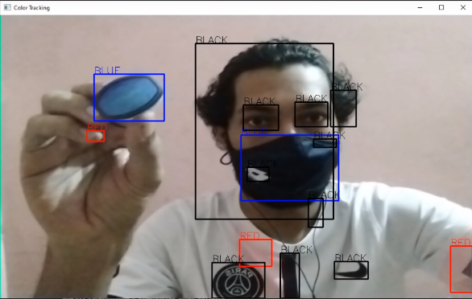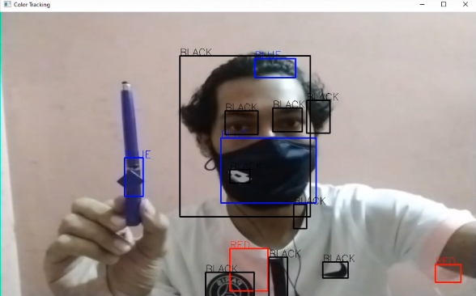

Here we can see the system successfully detected the colors of different objects presented by one of our team members. The amount of colors was kept minimal as in low resolution camera the pixels were scattered and it could affect the performance of the system. But the colors can be added as user’s preference. Also the system may not be able to detect more complex color combination.

1. **Conclusion**

The color detection project can be expanded to cover various real life applications. In day to day surveillance systems the color detection can be implemented. We want to expand our project to such an application where we can implement color detection to detect if a person is wearing mask or not. Sometimes the mask’s color could be different and difficult to detect with a normal mask detection without any color detection system. This can be achieved by implementing color detection and mask detection together. In a pandemic situation we are in right now it can be very useful. We are looking forward to do more experimentation with this project to come up with new and innovative ideas that can be useful in real life scenarios.

**References:**

[**https://www.quora.com/Why-use-an-HSV-image-for-color-detection-rather-than-an-RGB-image**](https://www.quora.com/Why-use-an-HSV-image-for-color-detection-rather-than-an-RGB-image)

[**https://www.pantone.com/articles/color-fundamentals/how-do-we-see-color**](https://www.pantone.com/articles/color-fundamentals/how-do-we-see-color)

[**https://www.youtube.com/watch?v=nbwPPcwknPU**](https://www.youtube.com/watch?v=nbwPPcwknPU)

[**https://www.quora.com/What-exactly-is-HSV-What-does-an-HSV-version-of-an-RGB-image-represent**](https://www.quora.com/What-exactly-is-HSV-What-does-an-HSV-version-of-an-RGB-image-represent)

[**https://en.wikipedia.org/wiki/HSL_and_HSV**](https://en.wikipedia.org/wiki/HSL_and_HSV)